This document contains the screen-shot of the application while run it on locally and the later portion of this document contains the step for running this application.

***Screen-Shots***

1. Valid Details

confirmation number = 123456

Last Name = yadav

Email_id = vishal@abc.com

Contact Number = 9823561766

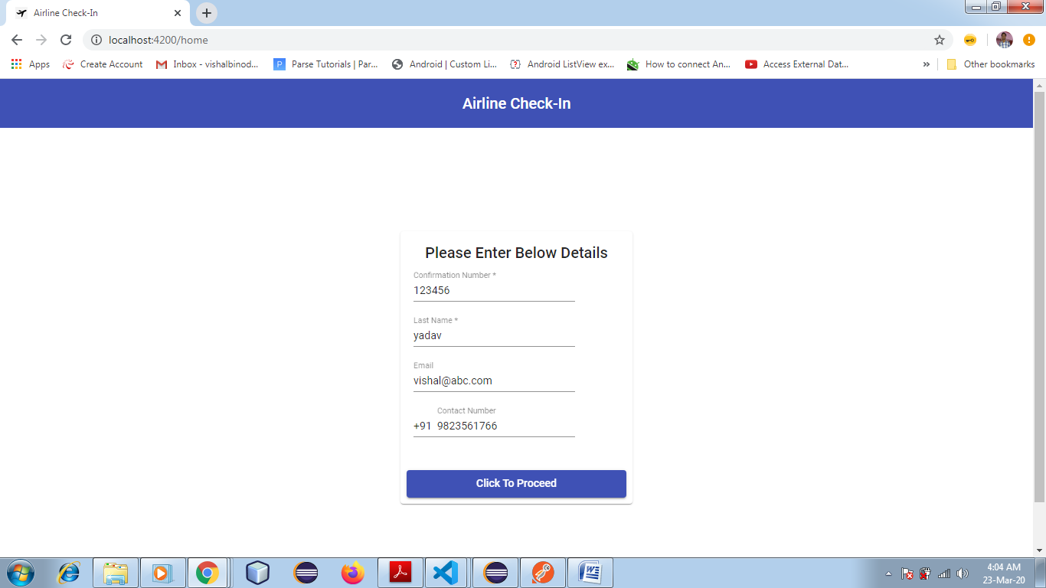

* Click "Click To Proceed" button

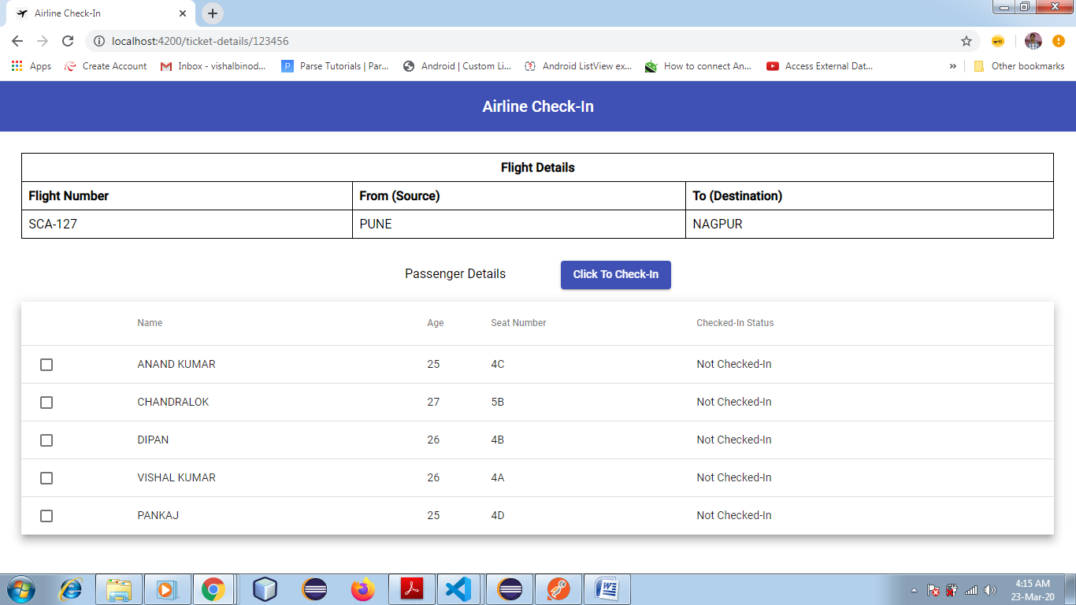

* Select the users for whom you want to do check-in

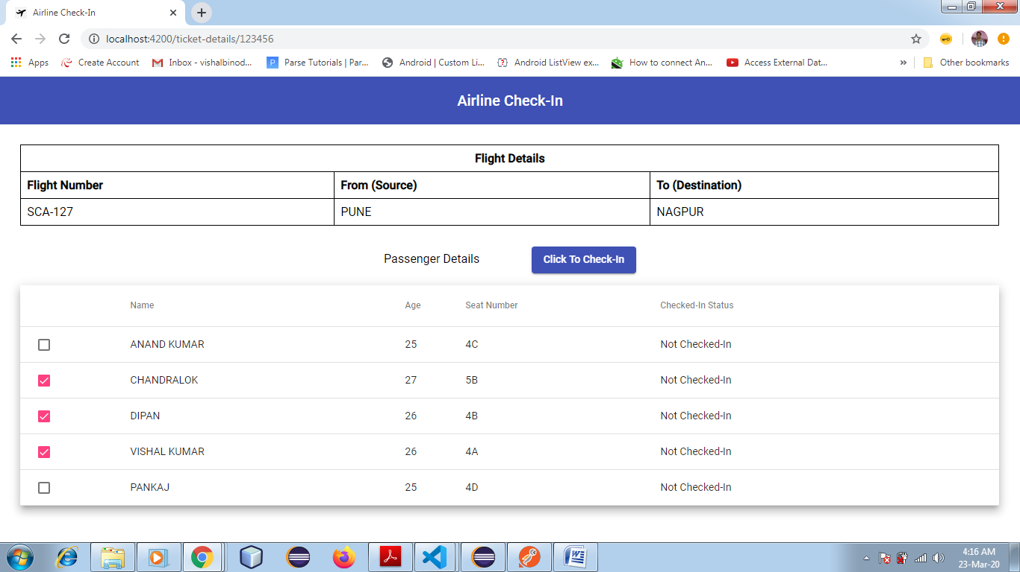

* Click on "Click To Check-In"

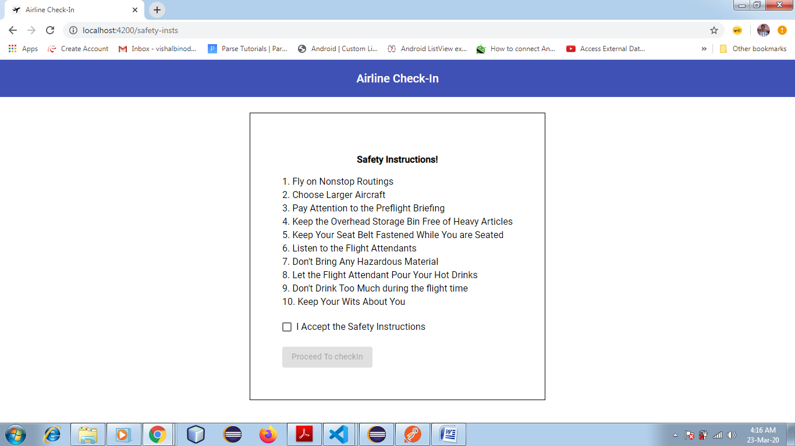

* Accept the Safety Instruction to proceed and then click on "Proceed To CheckIn"

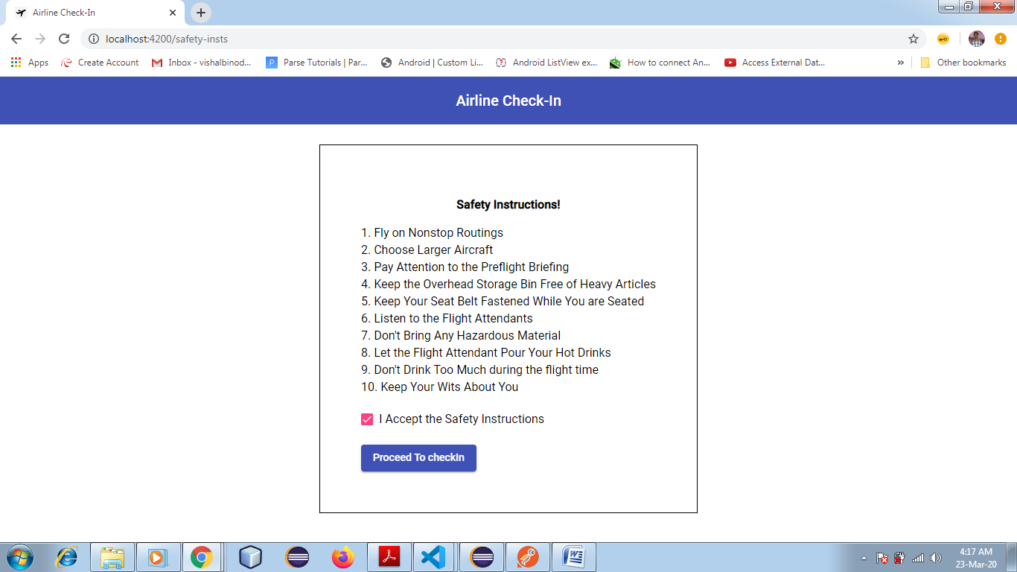

* View Boarding pass for the selected 3 users

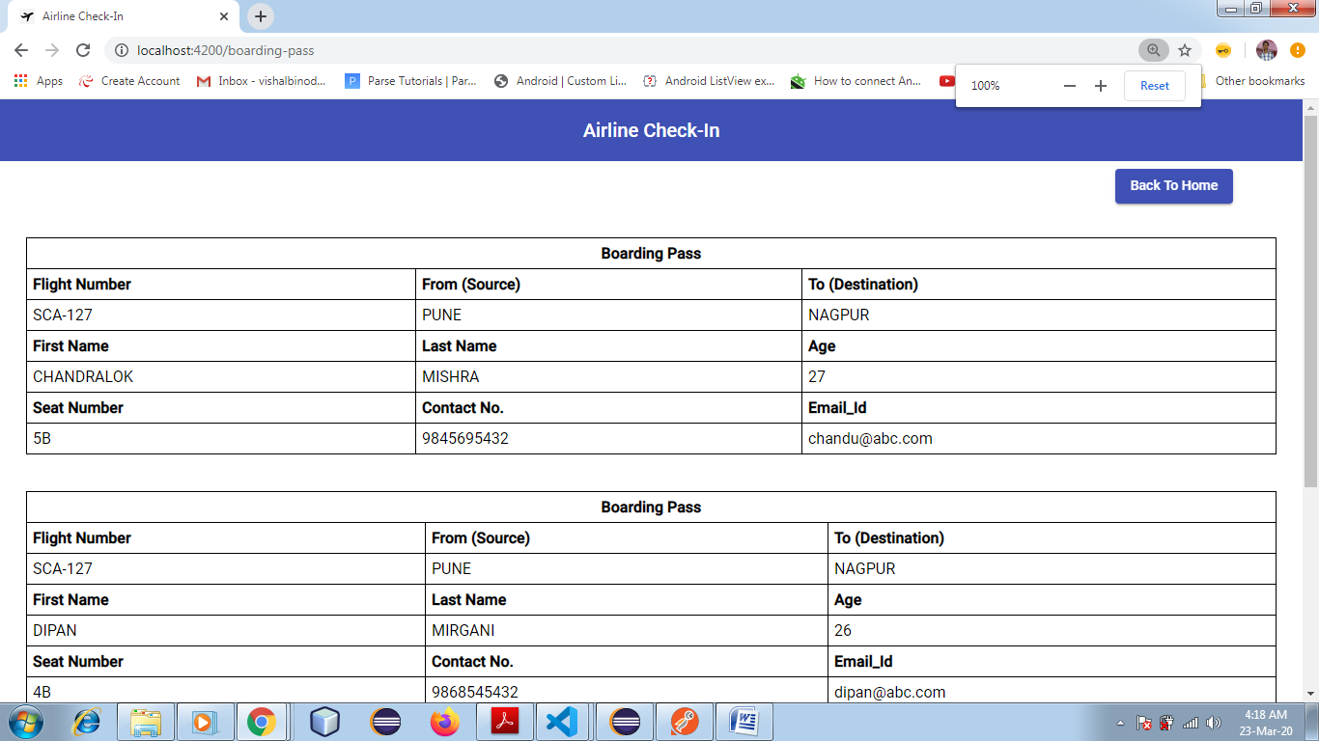

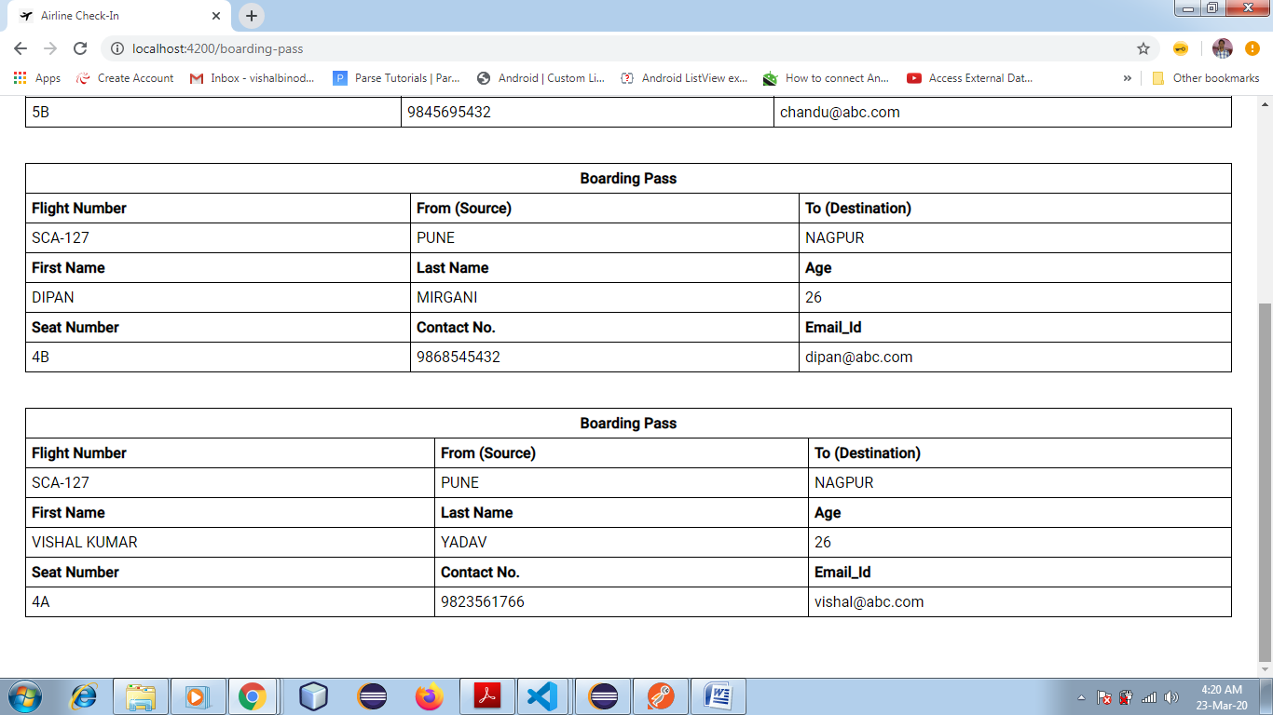

* Now only 2 users of the ticket is remaining for the Check-In prcocess.

* Click on "Back To Home" button to go back to the home page.

2. Performing the Check-in process for the remaining to 2 users

* Fill in the valid details once again

confirmation number = 123456

Last Name = yadav

Email_id = vishal@abc.com

Contact Number = 9823561766

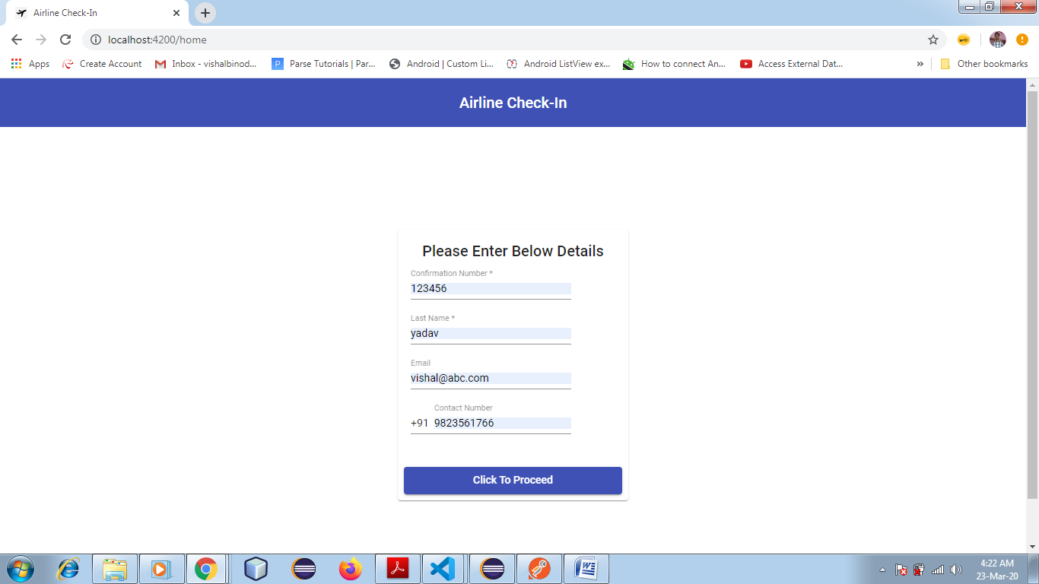

* Click on the "Click To Proceed" button

Now here you can see that, the check box is disabled for the already Checked-In user and the check box is enabled for the only 2 remaining user who have done their check-in.

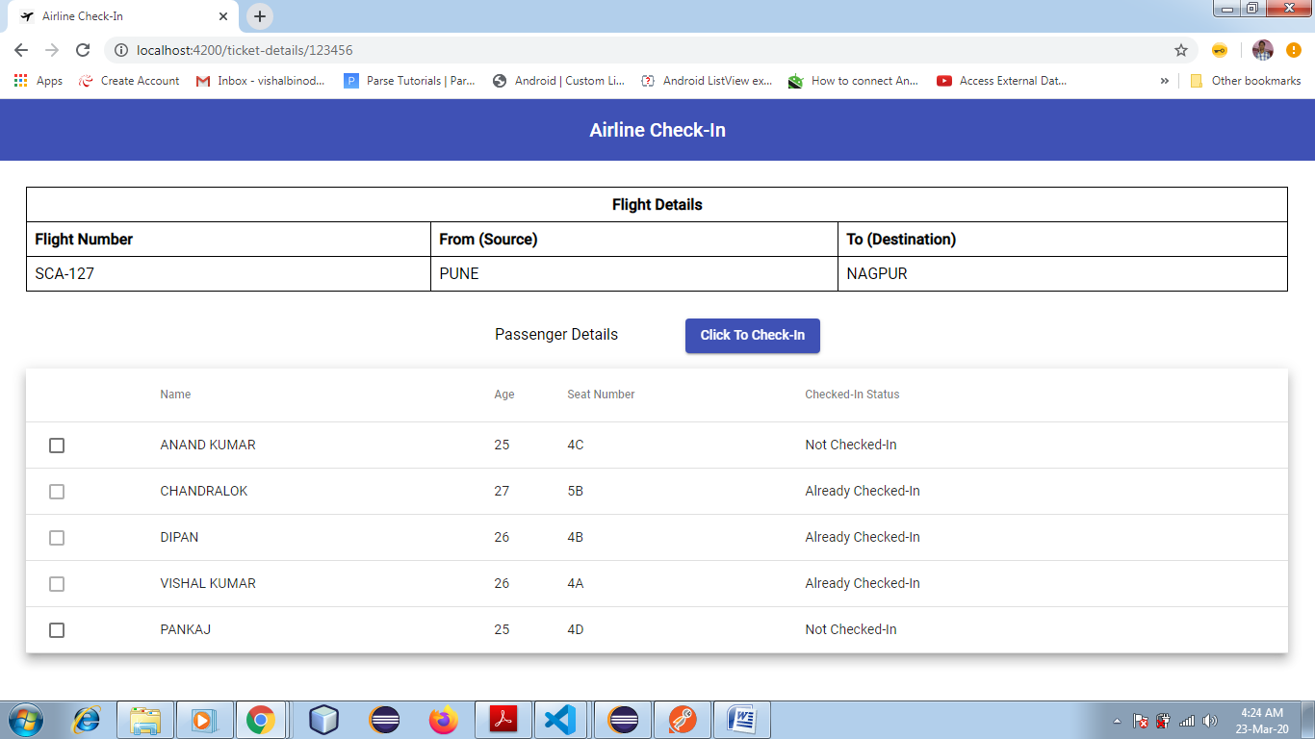

* Select the remaining two users as well to do their check-in and click on "Click To Check-In" button.

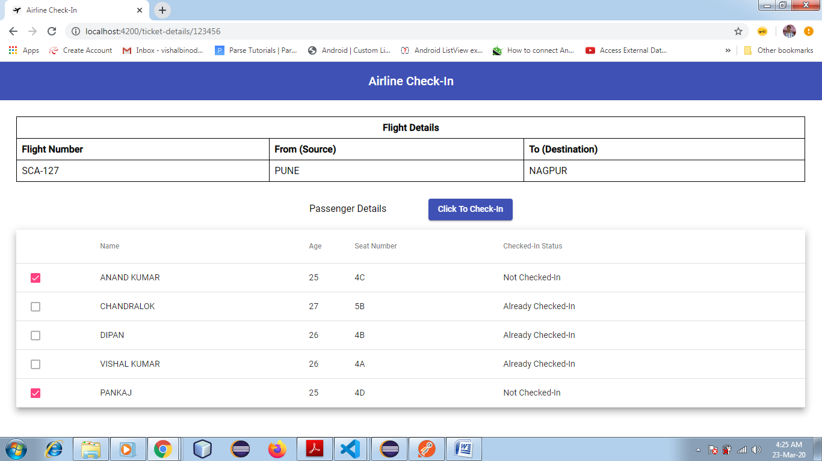

* Accept the safety Instruction and click on "Proceed To CheckIn" button

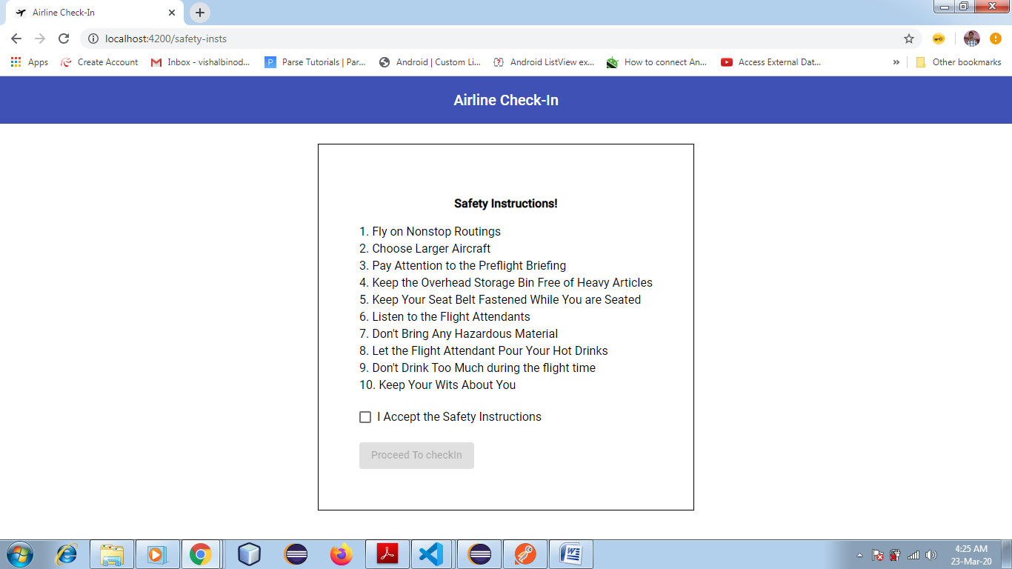

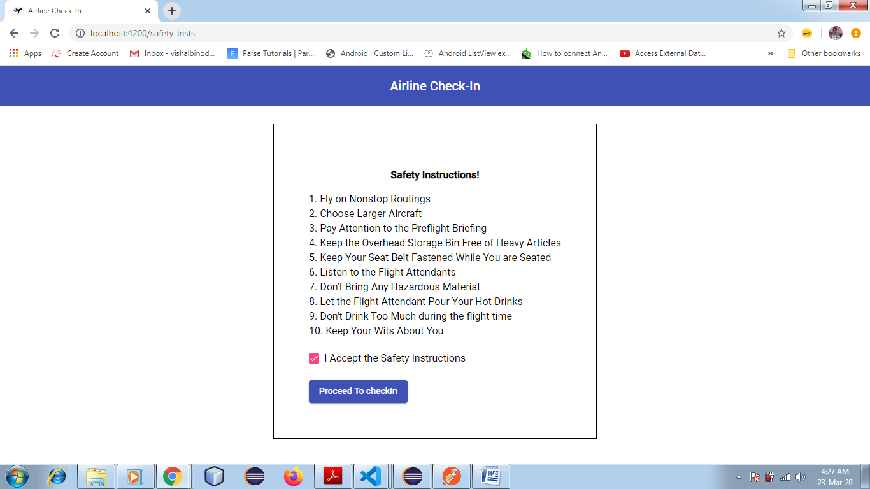

* Displays the Boarding pass details for the remaining 2 selected users

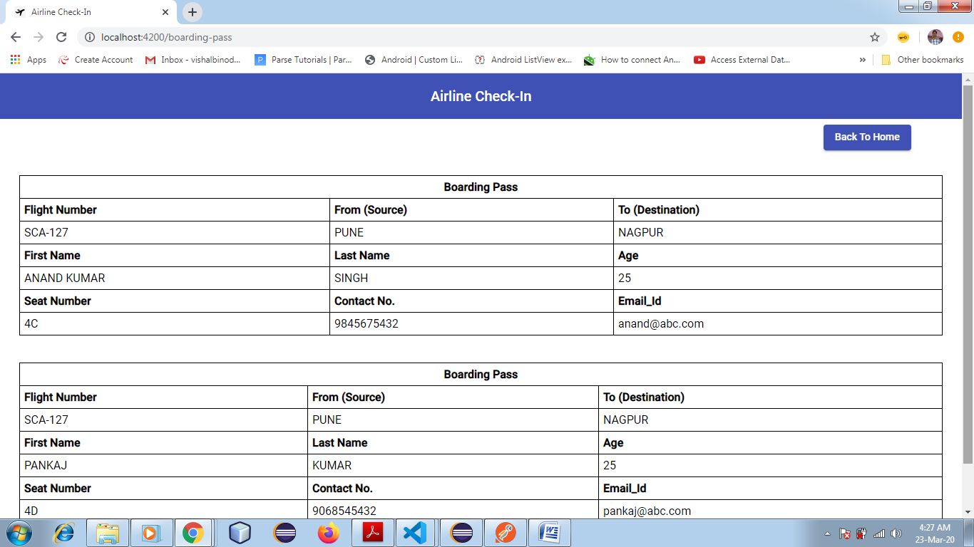

* Click on "Back To Home" button to go to the Home page.

3. Now we have done Check-in for all the users.

So, now if we will enter the same valid details then it will show the error message as "***You have already Checked-in***"

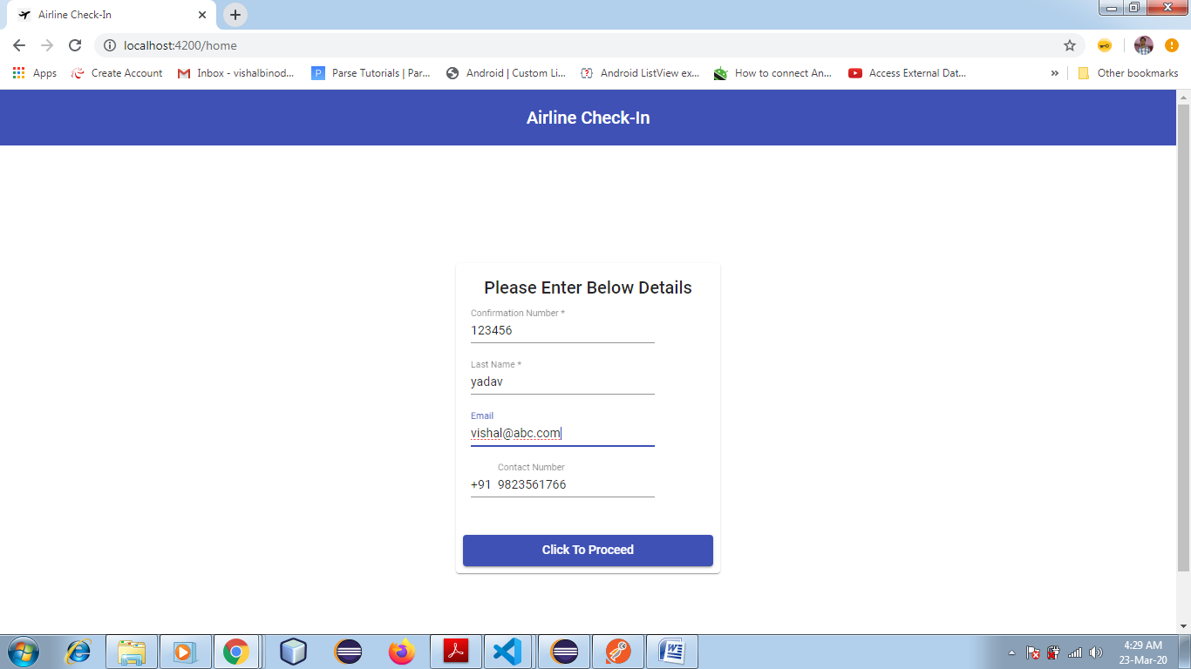

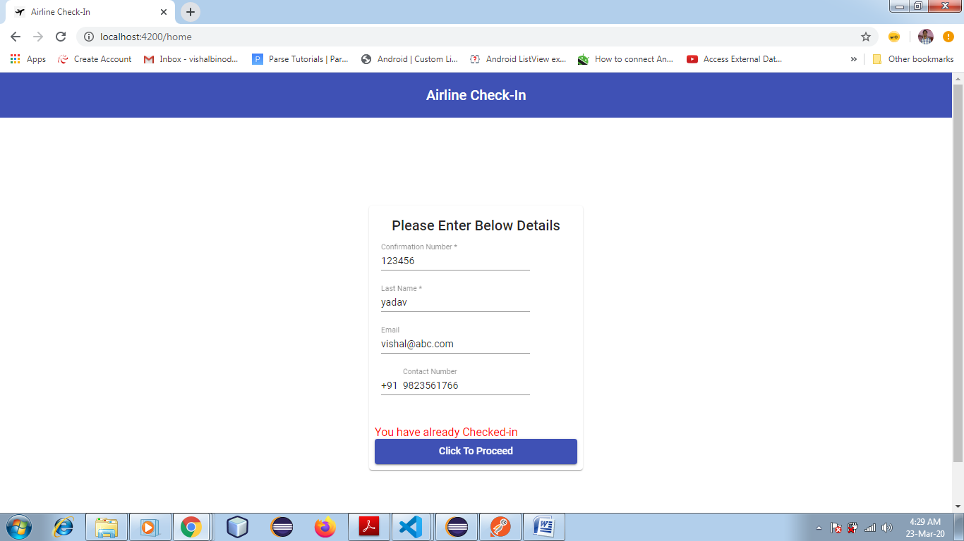

4. If we enter the invalid combination then we will get the following error message.

"***Invalid Details***"

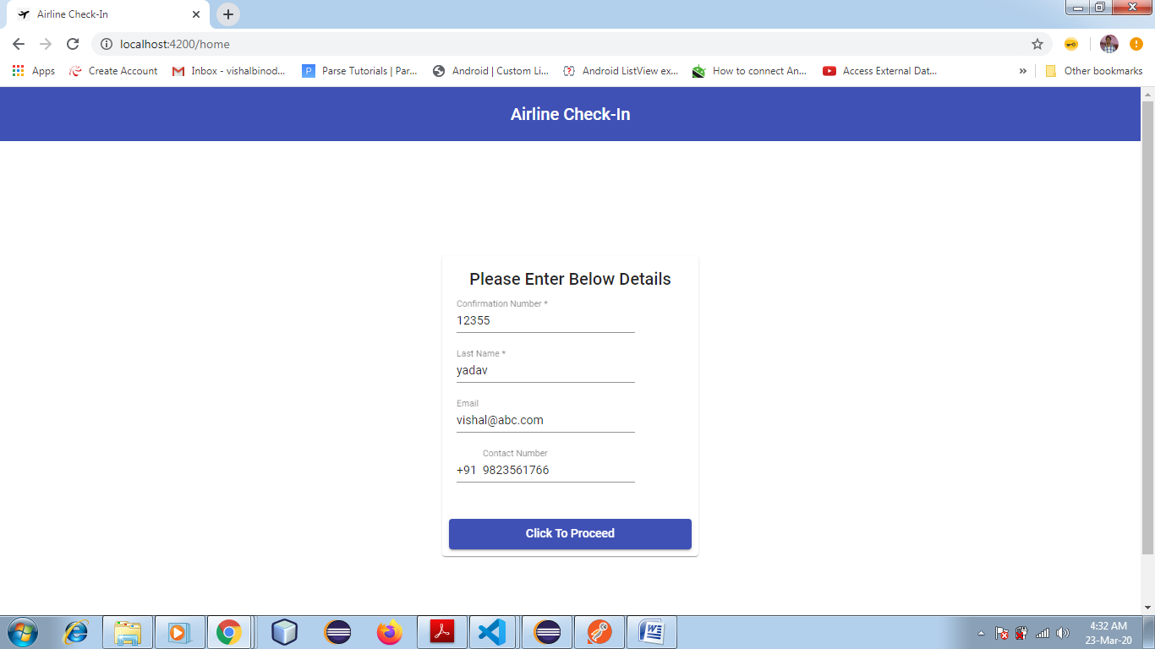

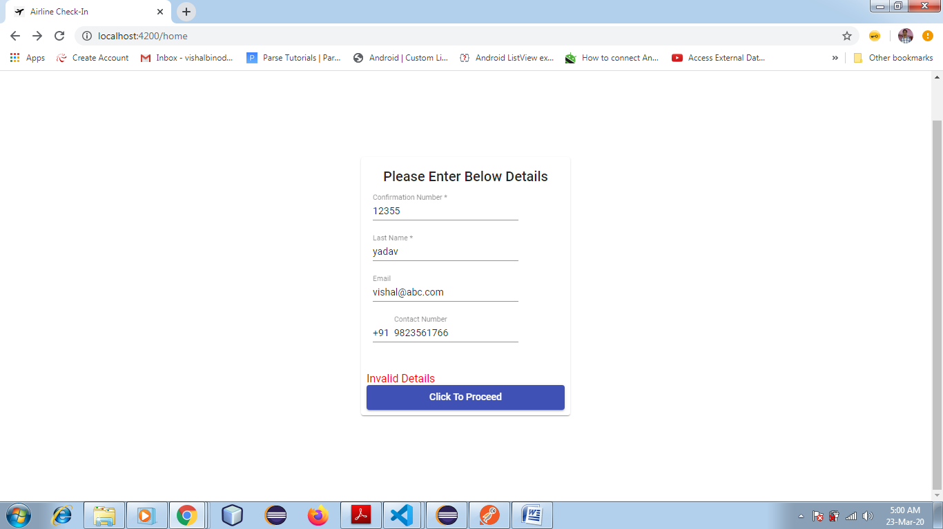

***Steps to Run this application***

1. Clone the Angular and Java Spring-boot (RESTApi)application from below GitHub link.

GitHub Link: <https://github.com/vishalbinodruplal/QuanteonTest>

2. Import the Java Spring-Boot application as a Maven project in your IDE

3. Run the Java Spring-Boot application first. The application will use 8080 port by default.

to change the port number add below line to "application.properties" file present under resource folder or simply run the program

4. Import the Angular project in you IDE and the compile and run the program using below command in you terminal.

"**ng serve -o**"

5. Now proceed with your inputs check.

***List of Valid Passengers along with flight details are:***

1. Flight

|  |  |  |  |
| --- | --- | --- | --- |
| **Confirmation Number** | **Flight Number** | **From** | **To** |
| 123456 | SCA-127 | PUNE | NAGPUR |
| 987654 | IN-133 | NAGPUR | PATNA |

2. Passengers on the flight tickets

|  |  |  |  |  |  |  |  |
| --- | --- | --- | --- | --- | --- | --- | --- |
| **Confirmation Number** | **First Name** | **Last Name** | **Age** | **Email_Id** | **Contact No.** | **Seat No.** | **Check-In Status** |
| 123456 | anand kumar | Singh | 25 | anand@abc.com | 9845675432 | 4C | false |
| 123456 | Chandralok | Mishra | 27 | chandu@abc.com | 9845695432 | 5B | False |
| 123456 | Dipan | Mirgani | 26 | dipan@abc.com | 9868545432 | 4B | False |
| 123456 | vishal kumar | Yadav | 26 | vishal@abc.com | 9823561766 | 4A | False |
| 123456 | Pankaj | Kumar | 25 | pankaj@abc.com | 9068545432 | 4D | False |

|  |  |  |  |  |  |  |  |
| --- | --- | --- | --- | --- | --- | --- | --- |
| **Confirmation Number** | **First Name** | **Last Name** | **Age** | **Email_Id** | **Contact No.** | **Seat No.** | **Check-In Status** |
| 987654 | Manish | Alaspure | 25 | manish@abc.com | 9841235432 | 4C | False |
| 987654 | Vipin | Sharma | 27 | vipin@abc.com | 9845975432 | 5B | False |
| 987654 | Parag | Kulkarni | 26 | parag@abc.com | 9868545745 | 4B | False |